Otterbein
United Brethren in Christ
Church

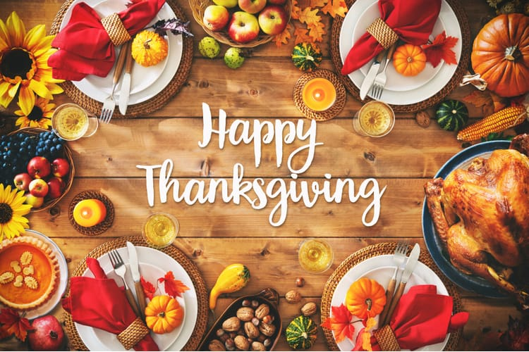

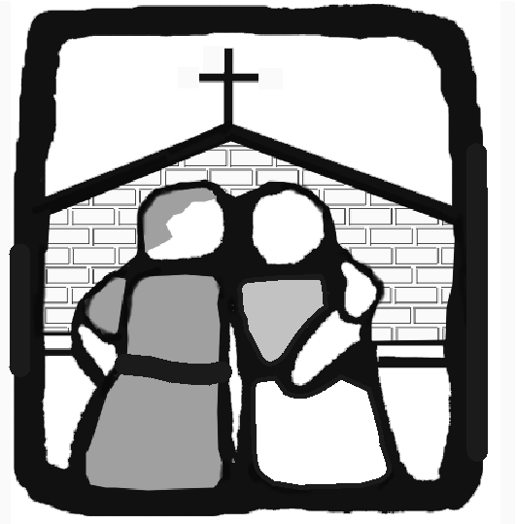
Connecting
Affirming
Reaching
Equipping
Sending

OTTERBEIN

A Church That
C.A.R.E.S.

146 Leitersburg Street, Greencastle, PA 17225

www.greencastleub.org

The Lord’s Day

November 29, 2020
Prelude
“For the Beauty” (Quartet) (Verse 4 screen)
Prayer
“Let us Praise Him” (screen)
Kids Korner
“Faith is the Victory” (screen)
Bible Message
“God Be with You” (screen)

Have faith in God when all else fails about you
Have faith in God, he provides for his own
He cannot fail though all kingdoms shall perish
He rules and reigns upon his throne
Have faith in God! He’s on his throne!
Have faith in God, he watches o’er his own.
He cannot fail. He must prevail.
Have faith in God! Have faith in God!

Again, this week we are doing worship services ONLY! No Sunday School Classes today or next Sunday. However, next Sunday the children will present their annual Christmas program during the S.S. hour. The program is taking into account the Covid situation as the children prepare and present. We hope you will be able to attend and receive their gift and message (Dec. 6 at 10:00)

We are also planning and preparing four our annual Christmas Eve Service. It will be done twice, December 23 and 24 (6:00). We trust that we will be able to space and share and celebrate together.

A G-A Community Thanksgiving Service was put together by Trinity Luther Church (Saundra Wingert for coordinating the service and Brandon Sidoli who taped and edited it.). The link is on the OUB website under “Sermon” or you can access it from the Trinity Lutheran website at www.tlcgreencastle.org May it bless and inspire you in this Thanksgiving Season.

Last Week | 11/22/2020
Attendance | 128
General | $ 8,053.00
Missions | $ 2,420.00
Building Fund | $ 1,735.00
Sunday School | $ 399.00
Pastor:
David Rawley
rawley1977@gmail.com
(717) 597-3211
Youth Director:
Josh Lance
597-8525 ext. 12
504-5604 (cell)
 | This Week | Next Week
1st Nursery | Gary & Daphne Murray | Tim & Holly Ressler
2nd Nursery | Ben & Cindy Widder | Cindy Rawley & Cheryl Bowen
Acolyte | EJ Fleming 1st  Loretta Wagaman2nd | Andrina Murray 1st  Ben Garrett 2nd
Prelude | Diana Gruver | Leta Sipes
joshlance85@gmail.com
Secretary:
Carol Schwalm office@greencastleub.org
597-8525
Hours 9 to 4 Tues/Wed/Thurs.
Building/Van Scheduling:
Holly Ressler
facility@greencastleub.org:
(717) 597-8525
Prayer Chain: 717-977-7751
or avstayman@comcast.net

Reminder... Administrative Board Meeting
Monday, Dec. 14, at 6:30

If you are interested in signing up for Secret Sisters 2021, the signup sheets are on the table downstairs. The deadline for signups is November 29.

Cancellation – The Ladies Christmas Tea is cancelled due to the increasing number of COVID cases in the community. An announcement regarding the logistics of the Secret Sister reveal will be forthcoming.

OUB 2021 calendars are available on the lower lobby desk.

One of our avenues of communication which helps keep in touch with needs is our prayer chain. Jenny Stayman (living in Florida) will put your request for prayer on the email chain to other families. Amazing! And we can all pray for and keep up with each other. If you would like to post a prayer need or get on the receiving list, contact Jenny at 717-977-7751 or avstayman@comcast.net. This is not done as an “activity” but as an expression of faith in the power of prayer (James 5:16).

If you don’t have, but would like to have a church mailbox and/or offering envelopes, please email your request to the church office
at office@greencastleub.org

