Otterbein
United Brethren in Christ
Church

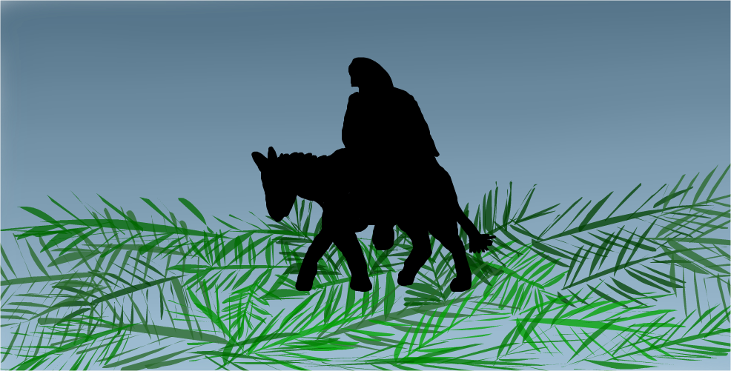

Connecting
Affirming
Reaching
Equipping
Sending

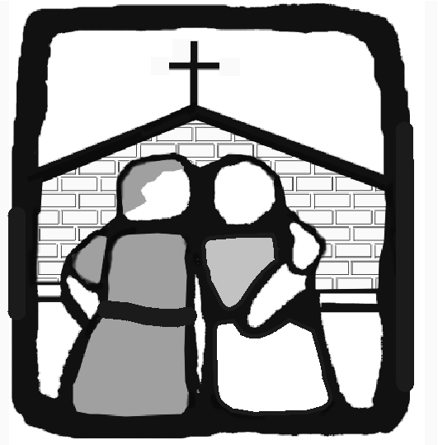

OTTERBEIN

A Church That
C.A.R.E.S.

146 Leitersburg Street, Greencastle, PA 17225

www.greencastleub.org
THE LORD’S DAY

April 14, 2019

TODAY
8:30/10:45 – Worship and Preaching
9:50 – Sunday School classes for all ages
6:30 – G-A Community LENTEN service at Greencastle Church of the Brethren
Music and Scriptures from various churches. Come and share in the Passion of Christ!

THURSDAY
6:30 – Maundy Thursday service at O.U.B. We focus on the burden and blessing which Jesus carried for us as he came into his Day of Suffering for the world. We share Holy Communion around the table as we remember his final meal

WELCOME TEAM
Apr. 7 – Tom & Christopher Keely
April 14 – The Widder Family
April 21 – Scott Garling
April 28 -Gary & Grant Murray
May 5 – Tom & Christopher Keely
Last Week
Attendance | 248
General | $ 6,719.00
Missions | $ 5,085.00
Building Fund | $ 4,014.00
Sunday School | $ 308.00

The altar flowers are given by Andy & Lori Webb in memory of Lori’s mother, Mae Oswald
April - First Service Ushers
Bob Stoner – Head Usher
Dick Bartles
Lynn Michalsky
Ed Tracey
Sean Tracey

Pastor:
 | This Week | Next Week
1st Nursery | Deb Michalsky & Amy Fleming | Garling Family
2nd Nursery | Loretta Robinson & Kristin Marconi | Cindy Rawley
Acolyte | Josh Rayarao 1st Keira Davis 2nd | Caitlin Horner 1st Saffron Lance 2nd
Greeters | Linda Mowen & Helen Orr | Ben & Cindy Widder Family
Prelude | Madalyn Akers | Becky Sipes
David Rawley
rawley1977@gmail.com
(717) 597-3211
Youth Director:
Josh Lance
597-8525 ext. 12
504-5604 (cell)
joshlance85@gmail.com
Secretary:
Carol Schwalm office@greencastleub.org
597-8525
Hours 9 to 4 Tues/Wed/Thurs.
Building/Van Scheduling:
Holly Ressler
facility@greencastleub.org: 597-8525
Prayer Chain: 597-2531
or Melarl@aol.com
EASTER SUNDAY
6:30 am – Sunrise service at the G-A School Farm pavilion
*Worship services at regular times next week
(No S.S. classes)

The 2019 National Conference for the United Brethren church will be held July 18-20 at Bowling Green (University), OH. Delegates make administrative and doctrinal decisions and hear reports regarding the U.B. denomination. If you have an interest in serving as a delegate for Otterbein to this conference, please speak with Pastor David. O.U.B. church membership is a requirement. More info at www.ub2019.org.

JUNE 2 - OUB Day Away/Summer Picnic
*Note change THIS IS ON SUNDAY NOT SATURDAY
- a.m.= combined service at OUB
- p.m. = baptisim/service and meal at Rhodes Grove Camp Pavilion

MAY 4 (Saturday)
Ladies, it’s your MOTHER?DAUGHTER Banquet … bring all the women in your family!
TIME = 5:30 PLACE = OUB Gym PROGRAM = Hats Off!
COST = Donation FOOD = Provided by the guys! QUESTIONS = Fran Stoner (717-597-0189)

MAY 5 (Sunday)
An evening of WORSHIP music of all types … our SPRING SING, 6:30. We need volunteers for music – vocal and instrumental. SO call Ryan Eberly (717-655-0157) and volunteer someone (even yourself)! Food/Fellowship afterward. COOKIES NEEDED … please see sign up sheet on entryway desk

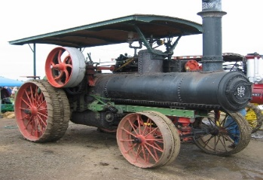
TWIN BRIDGES STEAM & TRACTOR SHOW – 12 volunteers needed for kitchen help on April 27 from 10:00 – 1:30. Through this work, a donation is made to missions. If you are available, please contact Trudy Norris (717-597-7789 or enorris@comcast.net )
This Photo by Unknown Author is licensed under CC BY-SA

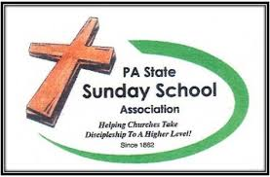
Monday, April 29, 6:00-9:00 Teaching to Change Lives seminar sponsored by PA State Sunday School Association - This is a training event for Sunday School teachers with great information to make your teaching more effective, no matter what age group. Evening includeS full meal. Cost is $30 of which OUB will pay half. Please contact the church office to register. Held at Hoss’s Steak and Seafood in Chambersburg.

Spring is here, which means the grill will soon be fired up for RALPH’S RECIPE BBQ Chicken! Saturday, April 27 … chicken available 9:00 – 1:00. All proceeds benefit our Guiding Hands Preschool (which is already filled for the 2019/20 year).
*If you would be willing to donate any baked goods, please bring them to the BBQ during the morning (cookies, brownines, bread, pies, etc). WHERE? Parking lot of Greencastle Bronze and Granite along Rt. 11.

